

**North Penn**

**Electronics**

**Reflow Control Box**

**Assembly Kit**

**Joshua Irwin Ryan Cox**

**Theory of Operation**

When working with Surface Mount Technology, the normal soldering that North Penn utilizes would not be sufficient enough to make circuit boards with surface mount components efficiently. We realized that we needed to utilize a device called a reflow oven. A reflow oven monitors the temperature inside of the oven and adjusts the temperature as necessary so that the solder melts fully to form a solid solder joint and at the same time making sure that the oven doesn’t increase or decrease too rapidly, causing thermal shock. When compared to through-hole soldering, reflow soldering requires less work once you have a functional oven, but much more precision due to the fact that both the solder and the flux are contained in a single mixture called solder paste. This paste has to be carefully applied to the circuit board so that is covers the component leads, but not too much so that it will bridge between the two leads, causing a short.

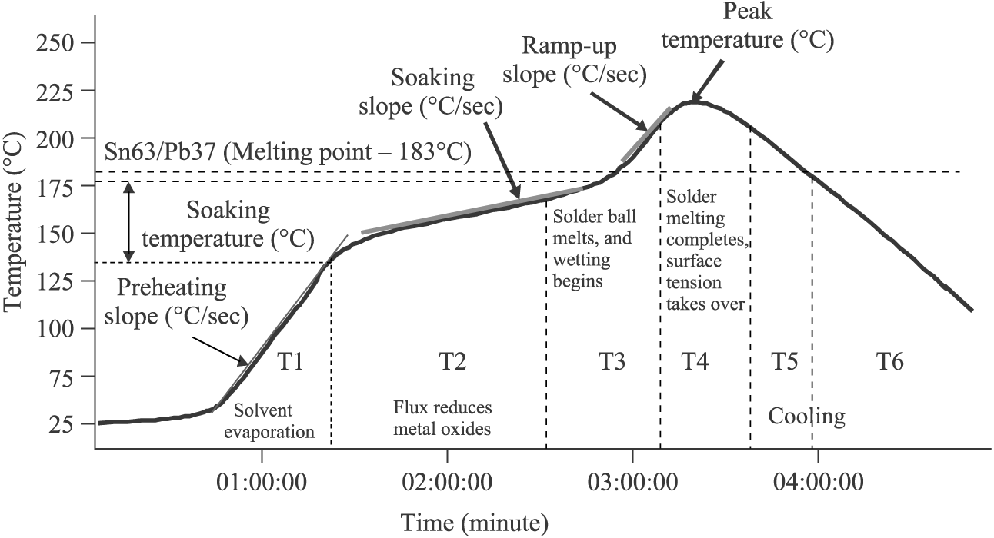

In addition to monitoring the internal temperature of the reflow oven, the oven must also follow a specified temperature curve so the solder joint is of high quality. This is done by ensuring that the solder alloy and the base metal reach the minimum soldering temperature for a sufficient amount of time. This temperature curve is called a thermal profile and consists of five stages.

Standard Reflow Temperature Profile.

The first stage is called the Ramp-to-Soak (RTS) stage. In this stage, the oven goes from ambient temperature to about one hundred and fifty degrees Celsius, plus or minus twenty degrees. Once the temperature is around one hundred and fifty degrees, the second stage, called the Soak stage begins. It is here that the board and solder alloy rise in temperature for about forty-five seconds so that they are around the same temperature. Once the time has passed, the third stage, called the Ramp-To-Peak stage begins. This stage is essentially the same as the Ramp-To-Soak stage as it simply raises the temperature to about two-hundred and seventeen degrees Celsius, at about one to three degrees per second. Once the temperature reaches two hundred and seventeen degrees Celsius, it holds the temperature for about forty-five seconds as well to ensure that the solder bonds evenly with the joint. Once the given time has elapsed, the cooling stage begins. The cooling stage essentially just turns off all heat output and limits the temperature drop to about one to three degrees per second. This limit is imposed so that the board and component don’t suffer from thermal shock and cracking. If every stage goes well, there should be a high quality solder joint between the board and the component. We created this control box to replicate this profile.

**Required Items List**

**Tools Required:**

* Soldering Iron
* Wire cutters
* Wire strippers
* Solder (Lead-free)
* Drill Press
* Drill
* Jig Saw

**Parts List:**

* C1 - 22 pF Capacitor
* C2 - 22 pF Capacitor
* C3 - 22 pF Capacitor
* 1 NPN Transistor
* R1 – 1200 Ohm Resistor
* R2 – 3300 Ohm Resistor
* Screen – Adafruit 16 x 2 Standard LCD
* Contrast Control – 10K Ohm Trimmer Potentiometer
* 1 Outlet Socket
* About 5 Feet of 22-Gauge Solid Core Wire
* 7 Foot Extension Cord
* 4 in. x 4 ½ in. Single Sided Copper Board
* Buzzer – 5 Volt Piezo Buzzer
* S1 – Pushbutton (Start)
* S2 – Pushbutton (Stop)
* K-Type Thermocouple – Adafruit MAX31855
* 16 MHz Frequency Crystal
* Microprocessor – Atmega328 (Duemilnova Bootloader)
* 28 pin DIP Socket
* Break Away Male Header Pins
* Break Away Female Header Pins
* USB-to-Type M Barrel 5V DC Cable
* Type M Female Coaxial Power Connector
* 7x5x3” Project Box
* 6 Insulated Spade Terminal
* 25 Amp Relay (24-380V AC, 3 -32V DC)

**Kit Assembly Instructions**

***Verify you have all of the required parts for this kit***

**Prepping the Printed Circuit Board**

1. Begin by opening the file called “Four Copy Mask” at “(*Where folder is saved to)*\Reflow Control Box\PCB Mask\Four Copy Mask”. ***(Edit when directory is set)***
2. Once the document is loaded, open the printer tray and insert a piece of etchant paper into the tray, dull side up.
3. Return to the document and hit print.
4. You will have four copies of the circuit on the paper, cut out as many as you need and save the rest to reduce waste.
5. Clean a copper board that is about 100 mm X 100 mm with steel wool.
6. Lay the etchant paper on the copper board once it is cleaned.
7. Apply a small amount of tape to the side of the paper to keep it attached to the board, making sure none of the traces are covered.
8. Lay a piece of printer paper over the etchant paper and apply heat to the copper board evenly for about seven minutes with the iron, make sure the edges are heated as well, since most loss occurs there.
9. Once you have heated the board adequately, take it over to the sink and run cold water over it for a few seconds before removing the etchant paper, this can help obtain a better quality transfer.
10. If needed, touch up any gaps with a black sharpie.
11. Once the board looks ready, set it into a container of ferric chloride to etch the board.
12. Leave the copper board in the solution for about four hours to complete the process.

**Programming the Atmega 328**

1. While the board is etching, take this time to program the Atmega 328 micro-processor.
2. Open the Arduino program on a computer.
3. Once the program is loaded, go to file, then open.
4. Navigate to “C:\Local Disk\Arduino Codes\Reflow_Oven_Revision_7(Final)” and open the file.

***\*\*Mr. Boyer, I do not have the final code to the control box saved on my computer, it should still be one of your computers at this location.** (Edit once found)***

1. Get an Arduino Duemilnova and remove the IC chip from the board.
2. Set the blank IC chip into the Duemilnova and plug in the Arduino to the computer via usb.
3. Verify that the board type and com port are selected correctly in the Tools menu.
4. Press upload code to program the chip with the code.
5. Once the program says it’s done uploading the code, remove power from the Arduino and remove the IC chip.
6. Set the chip aside in a safe place where the pins won’t get bent.

**Finalizing the Copper Board**

1. Once the board is finished being etched, remove it from the Ferric Chloride solution and rinse it off.
2. Dry off the board then take a piece of steel wool and use it to remove the black mask on top of the traces.
3. Once the mask is removed, cover the traces in flux and tin the board.
4. Once the board is tinned, verify there are no breaks in and of the traces.
   1. If there is a break, take a piece of solid core wire and lay it over the break, solder it between the gaps to ensure a solid connection.
5. 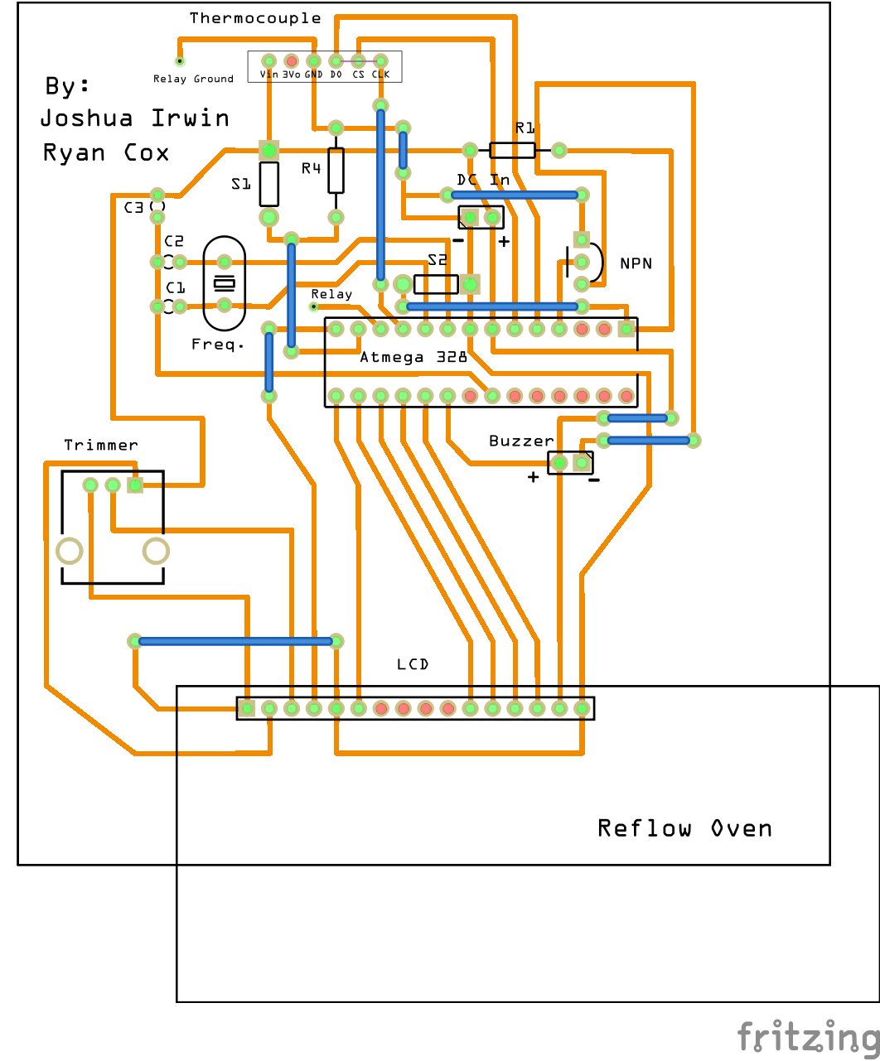Take the board over to the drill press and use a \*\***1/16th?\*\*** drill bit and drill holes into the board where the pads are, using diagram 1 as a reference.

Diagram 1

**Installing the Components**

1. Once the board is finished being drilled, begin installing the components one by one, leaving the two push buttons and the Type M Coaxial power connector aside to be installed later.
2. R1 is a 1200 Ohm resistor and R2 is a 3300 Ohm resistor.
3. For the LCD screen, solder in a row of 16 male header pins, leaving the screen to the side for now,
4. Follow diagram 2 to determine where each component goes, being sure to make verify polarity is correct.

Diagram 2

**Prepping the Case**

1. Get a7x5x3” box to house everything inside.
2. Get the top cover for the box and make a 2 ¾” x 1 7/8” rectangle at the top of the cover in the middle; this will be for the LCD screen.
3. Drill two 5/8” holes near the bottom of the top plate, spaced out evenly, these holes will be for the start and stop push buttons.
4. Get the main box and drill a 1 3/8” hole in the side of the box at the middle of it and a 1/8” hole about 3” away from it. The larger hole will be for the outlet socket, and the smaller hole is where the thermocouple will be located.
5. Drill two 3/8” holes in the back of the case (the end the LCD screen will be on), these holes will be for the AC and DC plugs.

**Wiring the Socket and Relay To AC**

1. Get the extension cord and cut away about 4” the socket end, save this for later.
2. Take the other end of the cord and feed it through one of the two holes in the back of the box, this will be your AC power cord.
3. Strip away about 3” off the exposed end and tin both wires.
4. Attach an insulated spade terminal and crimp to ensure a solid connection on both wires.
5. Connect the black wire to terminal 1(~) AC on the relay.
6. Take the cord we cut earlier, isolate and remove the black wire.
7. Strip and tin both ends and attach insulated spade terminals to both ends.
8. Attach one end of this wire to terminal 2(~) of the AC side of the relay, attach the other end of the wire to the brass screw on the outlet socket.
9. Take the white wire with the terminal on it and attach it to the silver screw on the outlet
10. Set the outlet into the hole that was drilled for it; make marks on the box where the brackets of the outlet are.
11. Drill in the screws where you make the marks, making sure they line up through the holes in the brackets.
12. Once the screws are all the way in, bolt them down to secure the outlet in place.

**Wiring the Relay To DC**

*Warning: After this step, the board will be connected to the box, make sure all other work is complete*

1. Cut a piece of stranded wire to about 4”, strip and tin both ends.
2. Attach an insulated terminal to one end of the wire.
3. Solder the other end into the hole that is labeled as “Relay”.
4. Take the end with the terminal on it and connect it to terminal 3(+) on the relay.
5. Cut another 4” piece of stranded wire, strip and tin both ends.
6. Attach an insulated terminal to one end of the wire.
7. Solder the other end into the hole labeled, “Relay Ground”.
8. Take the end with the terminal on it and connect it to terminal 4(-) on the relay.
9. 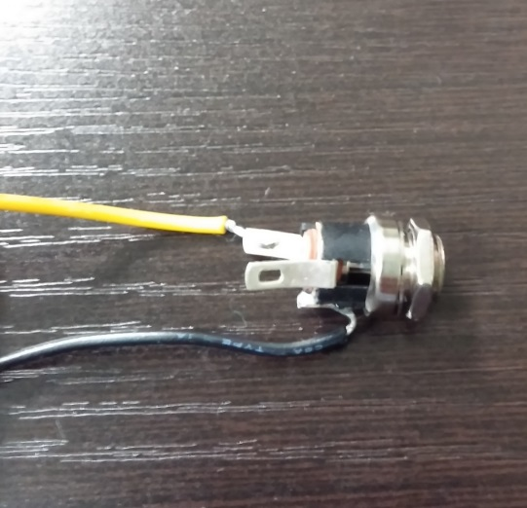Mount the relay onto the side of the box.

**Wiring the DC Jack**

1. Cut two pieces of stranded wire, about 4” in length.
2. Strip and tin both ends.
3. Solder one end of the positive wire onto either of the longer leads of the jack; solder the other end into the positive hole on the board. (Refer to Diagram 2 and 3 if needed)
4. Solder one end of the negative wire onto the short lead on the bottom of the jack; solder the other end into the negative hole on the board.

Diagram 3

1. Remove the bolt from the end of the jack, and feed the jack through the other hole at the back of the box.
2. Once the jack is through, screw the bolt back on to make sure it is secure; this will be where you plug in the DC power adapter.

**Wiring the Push Buttons**

1. Cut four pieces of wire. About 6”, for the push buttons.
2. Strip and tin both sides of every wire.
3. Solder a piece of wire onto each terminal of both push buttons.
4. Unscrew the bolt from the push button and feed both buttons through the top of the box.
5. Once it’s set, re-screw the bolts back on, and make sure both buttons are stable.
6. Wire the first button to the holes for S1, this will be your start button.
7. Wire the second button to the holes for S2, this will be your stop button.

**Wiring the LCD Screen**

1. Once everything else is mounted and secured, the final component to install is the LCD screen.
2. Looking at Diagram 2, the leftmost pin of the LCD screen is a square; this signifies that that is pin 1.
3. On the back side of the LCD, it should label which pin is 1 and which one is 16. Make sure that the pins of the board correspond to the pins on the screen.
4. Get a group of 16 Female/Female jumper wires and connected them from the headers on the board to the headers on the screen.
5. Once the screen is connected, mount it to the rectangular hole on the top of the case.
6. Once this is done, stick all parts of the circuit into the box, and you are now able to screw the top lid shut.

**Operation of the Reflow Control Box**

The operation of this box is fairly simple; you begin by supplying 5 volts of power to the DC input jack. This is made simpler by using a USB-to-Type M Barrel 5V DC Cable, by using this cable, you can easily use a standard power adapter from a phone charger, and it will supply the voltage that you need. If you do not have such a power adapter around, you can still plug the usb into a computer and use the power from that. When DC power is applied to the circuit, you should see the LCD screen light up, it will display the current temperature the thermocouple is reading, and the current stage that the control box is currently set at, it should read “Idle” until the start button is pushed.

After DC power is applied, you can plug the toaster oven into the outlet that is installed into the side of the box. Once it is plugged in, provide power to the AC circuit by plugging in the plug in the back of the box into any wall socket. Make sure the toaster oven is set to “Always on” and

“Broil” for best soldering results. Feed the probe of the thermocouple into the toaster oven and make sure it is positioned above the tray, without touching anything.

When you’re ready to begin soldering, apply solder paste over the pads where the components will be. Once you have the pads covered, gently set the component into place with a pair of tweezers and apply a slight amount of pressure to keep it close to the board. When the component(s) are set, hit the start button on the control box, the LCD screen should now list the stage as “Preheat” and it will run through the reflow cycle until it is finished.

The process of the cycle is the preheat stage, which keeps the board at about 120 degrees Celsius for about 1 minute, after that it begins its ramp stage and brings the board to about 200 degrees Celsius and keeps it there for about 30 seconds. Once the ramp stage is over, the oven turns off and the cooling stage beings, this slowly brings the boards temperature down and the buzzer will sound once two minutes has passed from the cooling stage beginning.